Your rotary spy cipher has been broken! You need to fix it to decode your next message!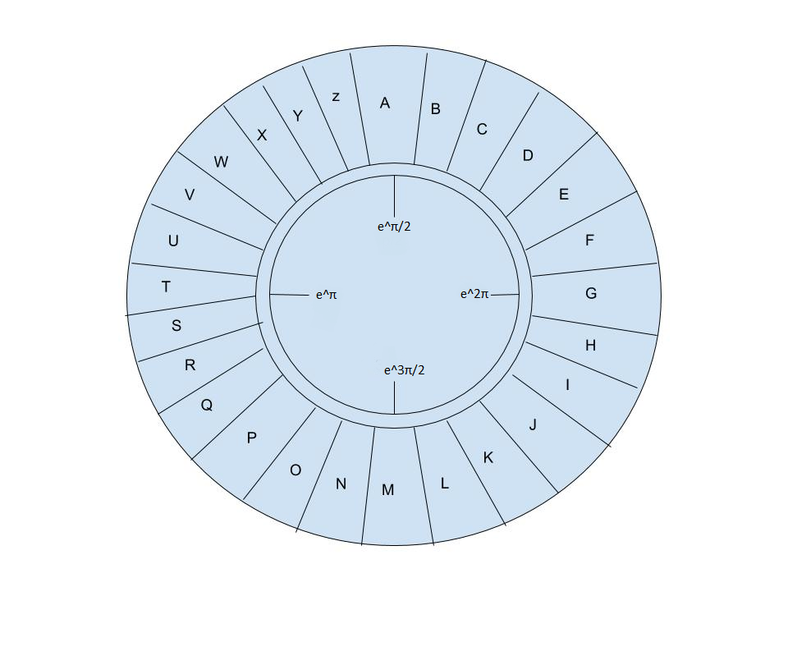

Your handler sent you the following encrypted repair instructions, and a message:

You’ve got to figure out which letter is #1 so that you can decode the message! Here are your Instructions:

{ #Instructions for rotary fail K&44805: Only what you cannot find can stay! }

|  |  |  |  |  |  |  |  |  |  |
| --- | --- | --- | --- | --- | --- | --- | --- | --- | --- |
| s | 1 | l | u | s | h | @ | e | a | ! |
| 0 | y | : | c | ^ | o | t | c | & | d |
| 3 | u | 5 | p | l | / | s | 2 | # | w |
| k | d | u | r | : | 8 | ! | r | i | . |

#Message: CW 1 15 18 1 19 2

Alphabetical message: ____ ____ ____ ____ ____ ____